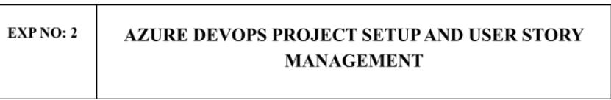
Aim:
To set up an Azure DevOps project for efficient collaboration and agile work management.
Project setup

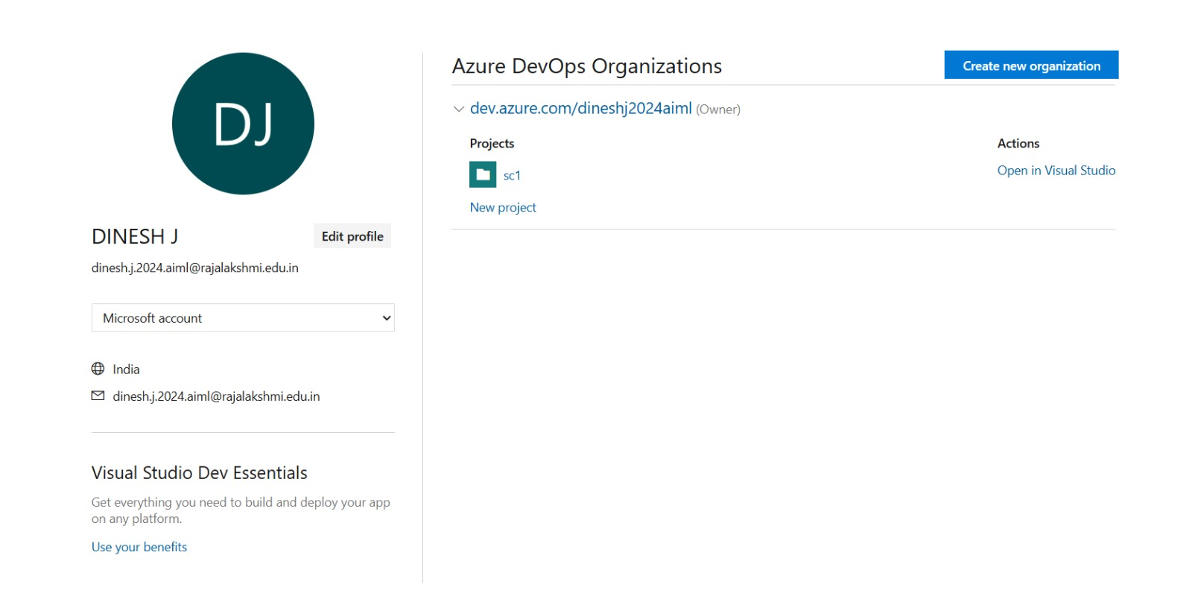

RESULT:
Successfully created an Azure DevOps project with user story management and agile workflow

